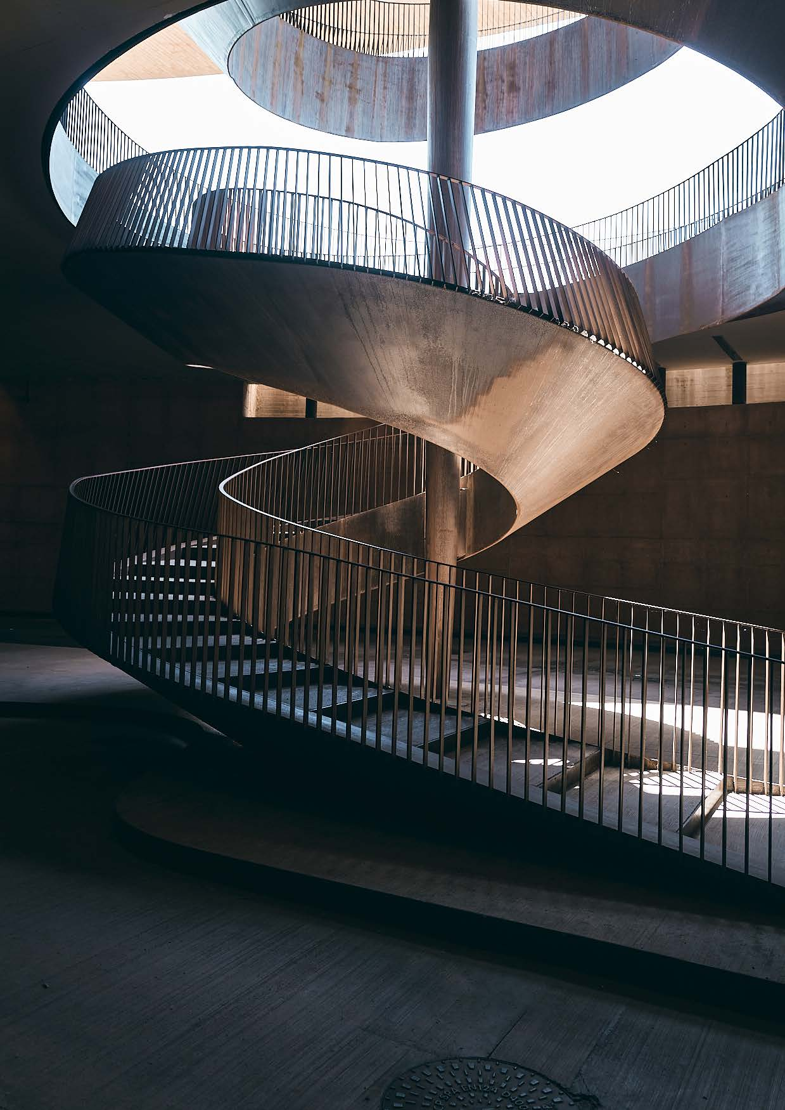

**BOOKING FORM**

ANTINORI “FAMILY ICONS” EXPERIENCE

**Date:** September 17, 2025 (Wednesday)

**Price per person** 1.000,00 Euro

**I hereby book the above-mentioned Range Rover Collective Experience for ___________ person(s).**

**Personal Information:**Please complete all fields in block letters and check the applicable boxes.

**1. Person** o **Mr** o **Mrs**

**\* Mandatory fields**

|  |  |
| --- | --- |
| Surname*: | Name*: |
| Street, Nr.*: | ZIP, Place*: |
| Telefon Number: | Mobile-Nr.: |
| E-Mail-Adress: | |
| Date of birth: | oVegetarian |
| Special requests / intolerances | |
| Current vehicle: | Second vehicle: |

**2. Person** o **Mr** o **Mrs**

**\* Mandatory fields**

|  |  |
| --- | --- |
| Surname*: | Name*: |
| Date of birth: | oVegetarian |
| Special requests / intolerances | |

**Included services:**

* Exclusive after-hours access to the Antinori nel Chianti Classico Winery
* Private guided descent through the winery’s architectural centerpiece, the iconic spiral staircase
* Scenic aperitif served in the vaulted barricaia (barrel cellar) with premium Antinori sparkling wine
* Curated tasting menu served in the panoramic glass dining room above the aging cellar
* Wine pairing with Antinori’s most distinguished labels
* Dedicated wine educator providing expert guidance throughout the evening
* Intimate group setting with limited availability to ensure exclusivity and discretion

*Subject to change.*

**Cancellation policy:**

We kindly ask for your understanding that, in the event of a cancellation after your participation has been confirmed, the following cancellation fees will apply:  
From the time of booking: 25% of the participation fee  
4 weeks prior to the event: 50% of the participation fee  
From 1 week prior to the event: 100% of the participation fee

**Payment method:**

**Bank transfer:**

Upon receipt of the confirmation, I will transfer the due amount according to the confirmation letter/invoice to the following account.

Bespoke Marketing GmbH Land Rover Club

Frankfurter Volksbank • BIC: FFVBDEFF • IBAN: DE87 5019 0000 6601 4049 56

______________________________ ______________________________________________

(Place and date) (Signature)

**Terms of Participation & Privacy Notice:**

The number of participants for this event is limited. Should the number of bookings exceed available spots, registration will be accepted in the order received. Bookings are only valid upon receipt of a written confirmation. Registration is binding. Upon confirmation, you will receive an invoice. The participation fee is due 4 weeks prior to the event date.

Please understand that in the event of a cancellation, cancellation fees will apply. You will find the applicable fees on the previous pages. Cancellations must be submitted in writing. We reserve the right to make changes to individual services if necessary after the conclusion of the contract, provided such changes are not substantial and do not affect the overall nature of the event. The event may be cancelled up to 35 days before the scheduled date if the minimum number of participants is not met, even after the registration deadline.

Jaguar Land Rover Deutschland GmbH is the organizer. Participation in the event is at the participant’s own risk. The participant waives all claims against Jaguar Land Rover Deutschland GmbH, its agents, and organizers for any material or personal damages incurred during the event. This exclusion of liability does not apply in cases of intentional or grossly negligent conduct by Jaguar Land Rover Deutschland GmbH, its agents, or organizers. The liability waiver also applies to any individuals associated with the organization of the event.

Jaguar Land Rover Deutschland GmbH reserves the right to postpone or cancel the event entirely for important reasons. No claims may be made by participants in such cases. The place of jurisdiction is Frankfurt am Main. Any disputes arising from or in connection with the participation agreement shall be governed by the laws of the Federal Republic of Germany.

**Privacy notice:**

Jaguar Land Rover Deutschland GmbH processes your personal data provided to handle your inquiry, organize the event, or facilitate the trip as part of your booking based on Article 6 Para. 1 S.1 b) GDPR.

This includes sharing your data with Bespoke Marketing GmbH, Georg-Büchner-Str. 1, 61476 Kronberg, info@bespoke-marketing.de, for the aforementioned purposes, particularly for the organization and execution of the event or trip. Additionally, we may use external service providers for data processing, who will process your personal data in compliance with applicable data protection regulations on our behalf and exclusively under our instructions within the EU.

Your personal data will only be stored as long as necessary for the above-mentioned purposes, i.e., for the fulfillment of the contract and to enforce or defend civil claims arising from contractual or statutory obligations until the end of the year following the expiration of the limitation period of respective mutual claims.

Further details about data protection and your rights can be found at [www.landrover.de](http://www.landrover.de/).

**I hereby acknowledge the privacy notice and agree to the terms and conditions above.**

______________________________ ______________________________________________

(Place and date) (Signature)

**Right of Withdrawl:**

You may withdraw your consent at any time, in whole or in part, by contacting Jaguar Land Rover Deutschland GmbH, Campus Kronberg 7, 61476 Kronberg, Email: info@thelandroverclub.de.

E-Mail: ____________________________________________________________________________________

**Please confirm your binding registration with your signature and send it to us via email to info@thelandroverclub.de, or by post to Bespoke Marketing GmbH, Georg-Büchner-Str. 1, 61476 Kronberg im Taunus. (The date of the postmark applies.)**

______________________________ ______________________________________________

(Place and date) (Signature)