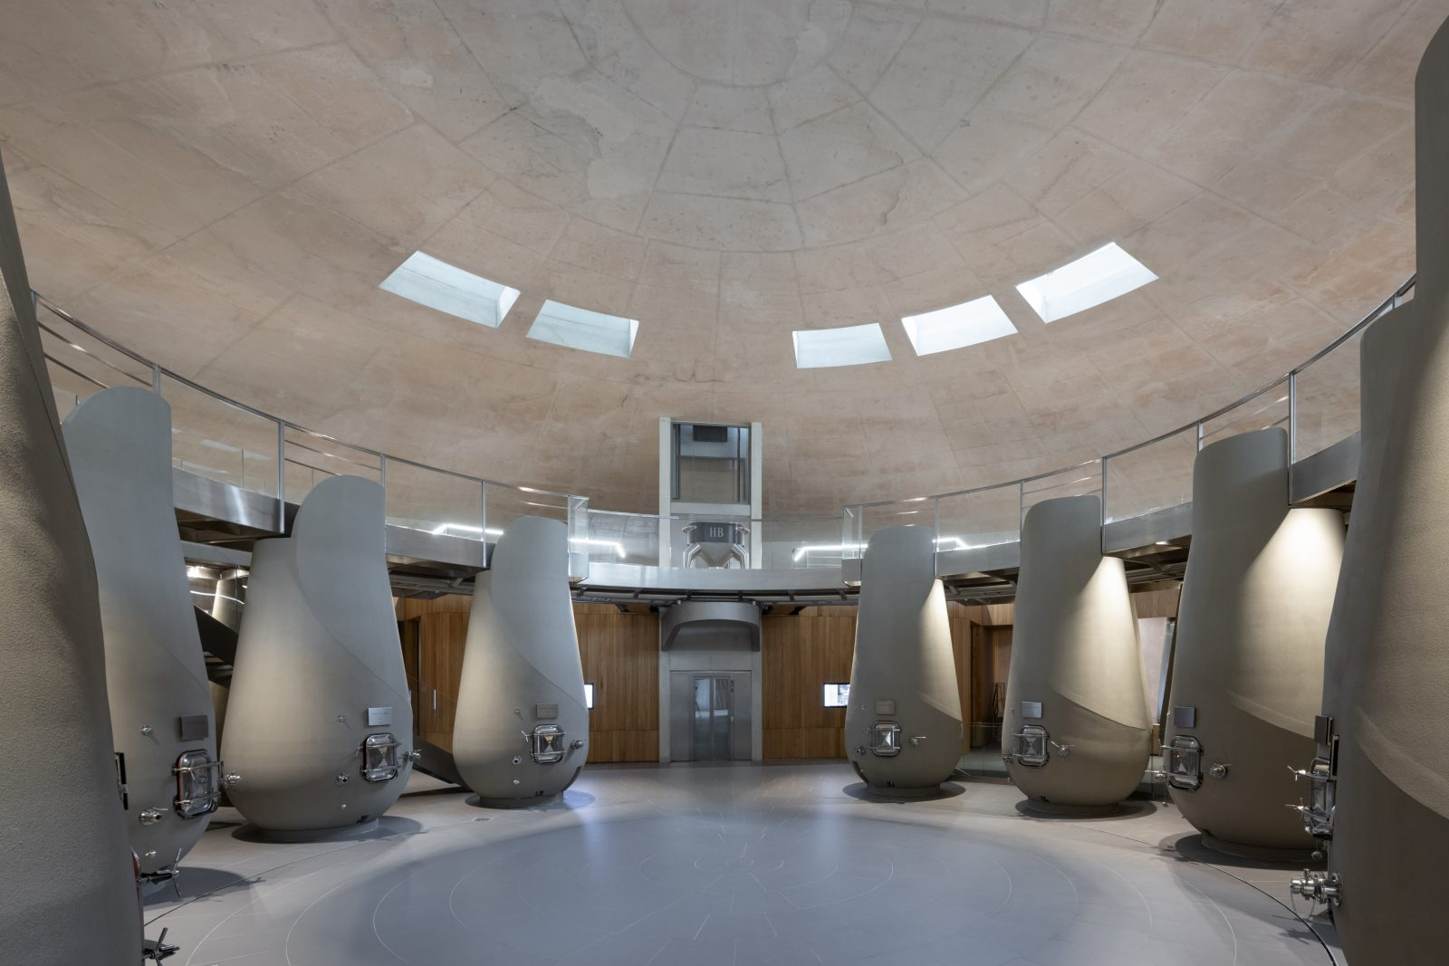

**BOOKING FORM**

BORDEAUX CAVIAR & WINE EXPERIENCE

**Date:** October 27 to 30, 2025 (Monday to Thursday)

**Price per person** 5.990,00 Euro

In a double room

**I hereby book the above-mentioned Range Rover Collective Experience for ___________ person(s).**

**Personal Information:**Please complete all fields in block letters and check the applicable boxes.

**1. Person** o **Mr** o **Mrs**

**\* Mandatory fields**

|  |  |
| --- | --- |
| Surname*: | Name*: |
| Street, Nr.*: | ZIP, Place*: |
| Telefon Number: | Mobile-Nr.: |
| E-Mail-Adress: | |
| Date of birth: | oVegetarian |
| Special requests / intolerances | |
| Current vehicle: | Second vehicle: |

**2. Person** o **Mr** o **Mrs**

**\* Mandatory fields**

|  |  |
| --- | --- |
| Surname*: | Name*: |
| Date of birth: | oVegetarian |
| Special requests / intolerances | |

**Included services:**

• Luxurious accommodation at the 5-star Hôtel Les Sources de Caudalie

• Private welcome reception in the iconic tasting tower

• Exclusive gourmet experience at Grand Cru Classé de Graves Château Haut-Bailly

• Caviar experience with private tasting and lunch

• Prestigious wine tasting & fine dining at Château Figeac

• Pure relaxation: Two-hour spa indulgence at the Caudalie Spa

• Personalized guidance by the Delicatours travel concierge

• Range Rover transfers

*Subject to change.*

**Cancellation policy:**

From the time of booking until 61 days before departure 30% of the total package price will be charged  
60 to 45 days before departure 45% of the total package price will be charged  
44 to 31 days before departure 50% of the total package price will be charged  
30 to 16 days before departure 75% of the total package price will be charged  
15 to 8 days before departure 90% of the total package price will be charged  
7 to 4 days before departure 95% of the total package price will be charged  
From 3 days before departure 100% of the total package price will be charged

**Payment method:**

**Bank transfer:**

Upon receipt of the confirmation, I will transfer the due amount according to the confirmation letter/invoice to the following account.

Bespoke Marketing GmbH Land Rover Club

Frankfurter Volksbank • BIC: FFVBDEFF • IBAN: DE87 5019 0000 6601 4049 56

______________________________ ______________________________________________

(Place and date) (Signature)

**Terms of Participation & Privacy Notice:**

The number of participants for this trip is limited. If more bookings are received than there are places available, the order in which they are received will be decisive. The booking is only valid after receipt of the confirmation. Registration is binding.

Please understand that cancellation fees will be charged if you cancel. You will find the cancellation fees on the previous pages. Cancellations must be made in writing! We reserve the right to make changes to individual services that become necessary after conclusion of the contract, provided they are not significant and do not affect the overall character of the event. Cancellation of the trip can also be declared to the participant after the registration deadline up to 35 days before the travel date if the minimum number of participants is not reached.

The participant takes part in the trip at his/her own risk. He waives any claims against Jaguar Land Rover Deutschland GmbH, its vicarious agents and organizers for damage to property and personal injury suffered by the participant during the event. The exclusion of liability does not apply if and to the extent that the participant's damage was caused intentionally or through gross negligence by Jaguar Land Rover Deutschland GmbH, its vicarious agents and organizers. The exclusion of liability also applies to persons associated with the organization of the event.

Jaguar Land Rover Deutschland GmbH reserves the right to postpone or cancel the trip for important reasons. Claims by the participant are excluded. Frankfurt am Main is agreed as the place of jurisdiction. Disputes arising in connection with or from the participation contract are subject to the law of the Federal Republic of Germany.

Delikatours Anke Wright is the exclusive organizer for Jaguar Land Rover Deutschland GmbH. With your signature you also accept the travel conditions of Delikatours Anke Wright. Notwithstanding the general terms and conditions of travel and payment, the above-mentioned terms and conditions of payment and cancellation apply.

**Privacy notice:**

Jaguar Land Rover Deutschland GmbH processes your personal data provided to handle your inquiry, organize the event, or facilitate the trip as part of your booking based on Article 6 Para. 1 S.1 b) GDPR.

This includes sharing your data with Bespoke Marketing GmbH, Georg-Büchner-Str. 1, 61476 Kronberg, info@bespoke-marketing.de, for the aforementioned purposes, particularly for the organization and execution of the event or trip. Additionally, we may use external service providers for data processing, who will process your personal data in compliance with applicable data protection regulations on our behalf and exclusively under our instructions within the EU.

Your personal data will only be stored as long as necessary for the above-mentioned purposes, i.e., for the fulfillment of the contract and to enforce or defend civil claims arising from contractual or statutory obligations until the end of the year following the expiration of the limitation period of respective mutual claims.

Further details about data protection and your rights can be found at [www.landrover.de](http://www.landrover.de/).

**I hereby acknowledge the privacy notice and agree to the terms and conditions above.**

______________________________ ______________________________________________

(Place and date) (Signature)

**Right of Withdrawl:**

You may withdraw your consent at any time, in whole or in part, by contacting Jaguar Land Rover Deutschland GmbH, Campus Kronberg 7, 61476 Kronberg, Email: info@thelandroverclub.de.

E-Mail: ____________________________________________________________________________________

**Please confirm your binding registration with your signature and send it to us via email to info@thelandroverclub.de, or by post to Bespoke Marketing GmbH, Georg-Büchner-Str. 1, 61476 Kronberg im Taunus. (The date of the postmark applies.)**

______________________________ ______________________________________________

(Place and date) (Signature)